Order No: 57 of 2026
Dated: 06-07-2026

Subject: Assignment of Duties.

The following assignments are hereby made with immediate effect:
- Er. Umar Mushtaq, Foreman, is assigned as In-charge of the Workshop Department of this institution.
- Er. Tooba Shah, Foreman, will take charge of the Academics Cell (1st and 2nd Semester).
- Ms. Haseena Akhter has been transferred to the Academic Cell.
All concerned are directed to handover/takeover the charges immediately and report compliance to the undersigned.

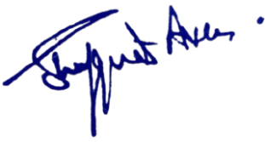

Dr. Shafquat Ara
No: KGP/Estt/2026/624
Dated: 06-07-2026

Principal
Kashmir Govt.Polytechnic College
Srinagar

Copy to the:
1. Er. Umar Mushtaq, Foreman for information and necessary action.
2. Er. Tooba Shah, Foreman for information and necessary action.
3. Ms. Haseena Akhter for information and necessary action.
4. All Concerned Officers/Officials of Workshop and Academic Cell for information.
5. Office file for record.

